Assignment 1

Question1:

* 1. Produce a visualization of SAMPLK3 which identifies both the groups described above and the most central actors.

Figure 1 Network Distribution SAMPLK3 by Group

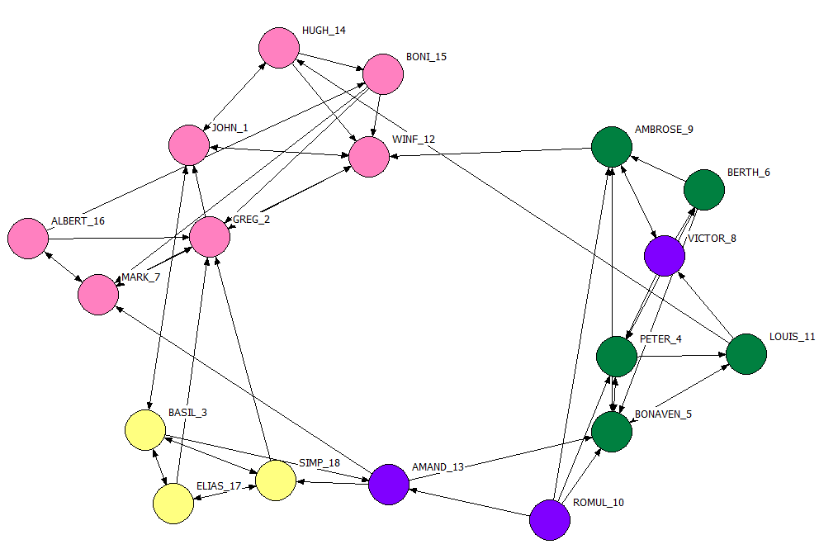

The four groups which presented by different hues, pink for “The Young Turks”, green for “The Loyal Opposition”, yellow for “The Outcasts” and purple for “The Floaters”.

There are a lot of approaches to identify the most centrality, which are degree centrality, closeness, betweenness, eigenvectors, etc. The degree centrality is the most basic and intuitive measure of centrality. Each vertex gets the value of importance by examining the total number of its neighbors, and divided by the sum of the degrees of the entire vertices.

In the figure 1, GREG_2 has the most ties in the group of “The Young Trucks”, Peter_4 has the most ties in the group of “The Loyal Opposition”, Basil_3 has the most ties in the group of “The Outcasts”, Victor_8 has the most ties in the group of “The Floaters. Therefore, GREG_2, Peter_4, Basil_3 and Victor_8 are the most central vectors in their each group.

* 1. How would you describe the roles of the most central actors in each group?.

The actors who have more ties to other actors may be advantaged positions. When they have a lot of ties, they will have alternative ways to satisfy needs, and hence are less dependent on other individuals.

With directed data, actors who have high degree, means the actors are able to exchange with many others, or make many others aware of their views. Hence, actors who display high degree centrality are often said to be influential actors.

* 1. What is the community structure of SAMPLK3?

There are four communities, which are “The Young Turks”, “The Loyal Opposition”, “The Outcasts” and “The Floaters”.

However, there are overlapped between “The Loyal Opposition” and The Floaters”, which identifies these two groups are close to each other. Victor_8 from “The Floaters”, AMAND_13 and ROMUL_10 from “The Loyal Opposition” are the connectors.

Non-overlapping communities between “The Young Turks” and “The Loyal Opposition”, which identifies these two groups are not close to each other.

Edge density is higher in the overlaps. Communities in the clusters of the network, the groups overlapping more, the thicker the tiles.

Question 2:

2.1 Examine SAMPLK1 and SAMPLK2 together with SAMPLK3, how have things changed over time? Produce a visualization that captures the changes.

Figure 2 Network Distribution for SAMPLK1 and SAMPLK2 together with SAMPLK3

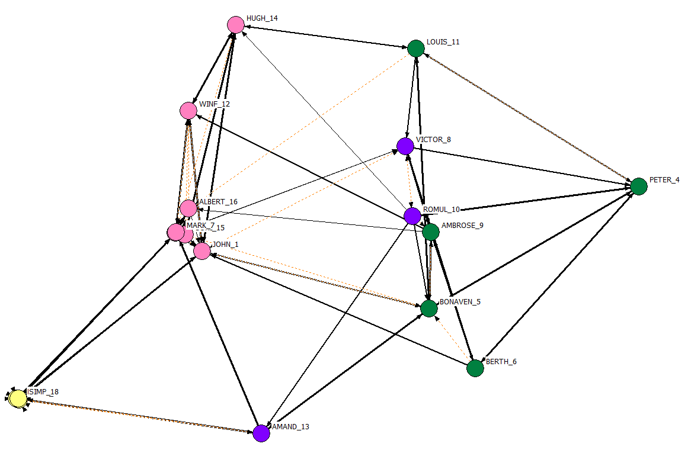

The the graph, orange dotted line presents for new added network, SAMPLK1 and SAMPLK2. The black solid line presents for the network SAMPLK3.

2.2 By examining the network do you think Sampson was correct in his group identification and description of the groups?

Most likely yes, however there are some conflicts. From Metric MDS of Value graph, VICTOR_8 and ROMUL_10 more and more close to green group and isolate from AMAND_13. Hence, I would like to say VICTOR_8 and ROMUL_10 have the high chance belong to the group of “The Loyal Opposition”.

2.3 Use the Qudratic Assignment Procedure to test Sampson’s description at both time 1 and time 3. Discuss your results.

I have implemented QAP function in Ucinet with the network belonging to time1 (LK1) and time 3(LK3), respectively compared with the matrix for group attribute (1 presents for from the same group, 0 presents for different group)

Figure 3 Group Matrix

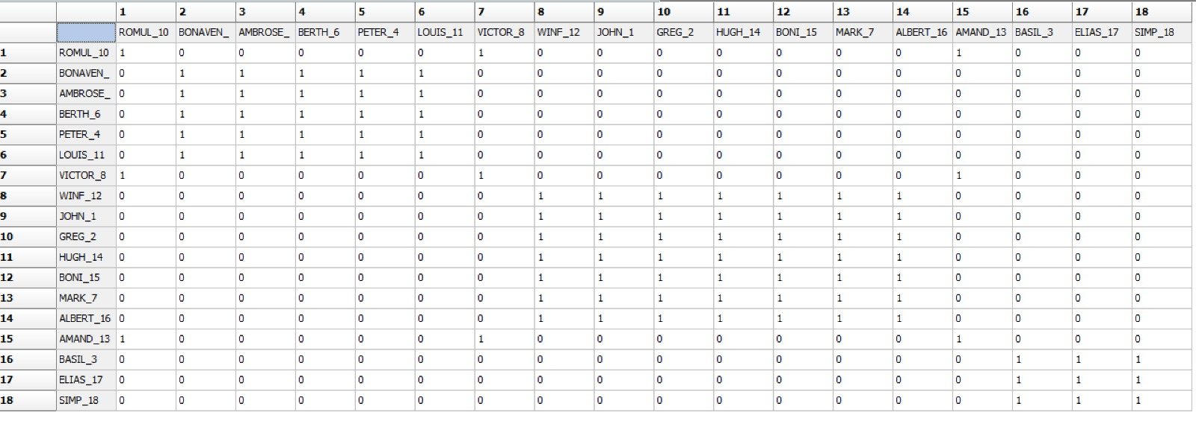

Figure 5.1 Result of QAP for time 1 and time 3

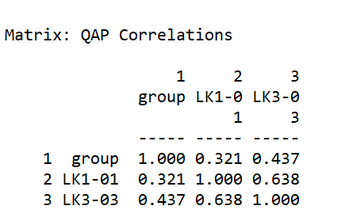

As you can see from the result, both time 1 and time 3 show positive correlation with group attribute. However, time 3 shows stronger than time 1.

Figure 5.2 Result of QAP for time 1 and time3

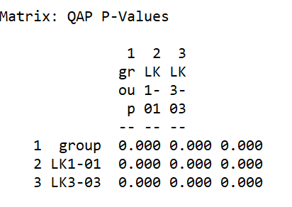

However, the p-value is 0, it means the null hypothesis is rejected and the test is statistically significant.